# 代码

### directory path

/export/lht/intern/src

### Commend

python train_model.py

python MW_Net.py for the meta-weight-net(Shu 2017) training

### Parameters

parser = argparse.ArgumentParser(description='uncertainty reweighting in noisy datasets')

parser.add_argument('--no_cuda', action='store_true', default=False,

help='enables CUDA training')

parser.add_argument('--visible_gpu', type=str, default="0,1,2,3",

help='visible gpu, in form "a,b,c,d"')

parser.add_argument('--seed', type=int, default=1,

help='random seed')

parser.add_argument('--log_interval', type=int, default=100,

help='how many batches to wait before logging training status')

parser.add_argument('--batch_size', type=int, default=128,

help='batch size')

parser.add_argument('--learning_rate', type=float, default=0.1,

help='learning rate')

parser.add_argument('--weight_decay', type=float, default=5e-4,

help='weight decay')

parser.add_argument('--momentum', type=float, default=0.9,

help='momentum')

parser.add_argument('--nesterov', type=bool, default=True,

help='nesterov momentum')

parser.add_argument('--milestones', type=list, default=[80,100],

help='milestones for learning rate scheduler')

parser.add_argument('--MC_n_samples', type=int, default=10,

help='number of sample in mc dropout')

parser.add_argument('--loss_debug', type=str, default="n",

help='n for nll, c for cross entropy, default is n just for debugging')

parser.add_argument('--n_var', type=int, default=10,

help='how many aleatoric uncertainty to predict, in yarin gal 2017 it was one for each class, but in deep bayesian self learning it is the same one for every class')

parser.add_argument('--model', type=str, default="rn",

help='wrn(wide resnet), rn(resnet) or dn(densenet)')

parser.add_argument('--net_arg', type=int, default=10,

help='growth rate for densenet and widden factor for wrn')

parser.add_argument('--depth', type=int, default=32,

help='depth of densenet(resnet is fixed 32)')

parser.add_argument('--dropout_prob', type=float, default=0.5,

help='the dropout ratio')

parser.add_argument('--lr_scheduler', type=str, default="multistep",

help=multistep, cosine, or cosine_m')

parser.add_argument('--num_classes', type=int, default=10,

help='how many classes in dataset(CIFAR 10 or CIFAR 100)')

parser.add_argument('--corruption_type', type=str, default="unif",

help='the corrution type in the training set, unif(uniform), partial_unif(only introduce noise between selected classes), flip, flip2(flip to 2 classes not one)')

parser.add_argument('--size_ratio', type=float, default=1,

help='use size_ratio*100% of the training set')

parser.add_argument('--train_class', type=list, default=range(0,10),

help='training set is composed of these classes')

parser.add_argument('--test_class', type=list, default=range(0,10),

help='testing set is composed of these classes')

parser.add_argument('--corrupted_classes', type=list, default=[0,1,2,3,4],

help='takes effect when corruption_prob=partial_unif')

parser.add_argument('--p0epochs', type=int, default=0,

help='number of epochs for phase 0(no reweight) to train')

parser.add_argument('--p1epochs', type=int, default=120,

help='number of epochs for phase 1(reweight) to train')

parser.add_argument('--corruption_prob', type=float, default=0.6,

help='the corrution ratio in the training set')

parser.add_argument('--reweight', type=str, default="none",

help='how to reweight, none, what(add entropy and variance), dbst(add a_pred and entropy), entropy(the entropy of the probability distribution), variance(the mean of the variance of [logit of each class in mc sampling]), a_pred(aleatoric uncertainty prediction), var_ratio')

parser.add_argument('--reweight_function', type=str, default="exp",

help='reweight function, exp(e^(-x)) or inverse(1/x)')

parser.add_argument('--reweight_norm', type=str, default="none",

help='reweight normalization, none, sig_m(sigmoid like function) or batch(normalization in mini batches)')

parser.add_argument('--loss_type', type=str, default="s",

help='type of loss, hm, hs, s')

parser.add_argument('--relabel_f', type=str, default="1",

help='frequency of relabeling and precision measuring')

parser.add_argument('--clean_only', type=bool, default=False,

help='train only on the clean part of the dataset')

parser.add_argument('--noise class', type=bool, default=False,

help='add a new class(noise class)')

parser.add_argument('--reweight_precision_thre', type=list, default=[0.1,0.3,0.5,0.7],

help='experiment parameter, calculate the precision of low weight sample in the first x*dataset_size sample with the lowest weight, same for the precision of high loss sample')

# Baseline复现（CIFAR10）

Denotation 请参见方法对比文档

## 无噪音

|  |  |  |  |  |  |
| --- | --- | --- | --- | --- | --- |
| clean data | baseline_model.py代码采用softmax+nll的计算loss方式 | baseline_model.py代码直接采用crossentropy的loss计算方式 | simple model（没有那些mcsample和不确定性的部件） | 网上的resnet trainer函数 | meta原文中写的 |
| wrn28-10(40 epoch) | 94.48 | 94.75 | 94.59 | 94.53 | 95.6 |
| rn32(60 epoch) | 91.15 | 92.22 | 92.16 | 92.22 | 92.89 |

## Flip noise

20% of one class is fliped half half to two classes, 0.8 are left for each class

|  |  |  |  |  |  |
| --- | --- | --- | --- | --- | --- |
| 0.2 flip2 | b nll | b cross | s | rt | meta原文 |
| rn32(60 epoch) | 89.17 | 89.55 | 90.16 | 90.17 | 76.83 |

## Uniform noise

40% of one class is divided into 10 classes, 0.64 are left for each class

|  |  |  |  |  |  |
| --- | --- | --- | --- | --- | --- |
| 0.4 uniform | b nll | b cross | s | rt | meta原文 |
| wrn28-10(40 epoch) | 89.42 | 89.41 | 89.14 | 85.07 | 68.07 |

# 伪代码

1. data loader:
   1. 用corruption prob与corruption type计算corruption matrix C
   2. 对每一个dataset中的图片：
      1. 判断是否为参与训练的类，若是则按照corruption matrix更改label，不是则加到mask里面最后从数据中删除
   3. 包装为data loader
2. test loader直接包装为data loader
3. 网络结构的py文件：直接在他人的resnet最后一层（输出层）做更改，10类变为输出20个logit（前十个是logit后十个为aleatoric uncertainty prediction）
4. 训练函数：
   1. 一个phase的训练函数：形参为第0或1phase，epoch数量
      1. 每个epoch：
         1. 先对训练数据集执行relabel函数，相当于一个test函数但会把根据网络输出算出的不确定度值转换为权重值，如果小于某阈值（即不确定性超过某阈值）的数据直接relabel到：预测值类/新噪声类
         2. batch循环，以下为每个epoch中一个batch的训练：
            1. 如果不reweight：

如果为cross entropy loss或者heteroscedastic single loss（hs）

MC sample一次

如果为heteroscedastic multi loss（hm）

MC sample 设定好的次数

MC sample的结果为(T,N,(n_class+n_var))

* + - * 1. 如果reweight：

MC sample 设定好的次数

* + - * 1. 计算loss

如果为cross entropy loss，直接计算得到batch中每个图的loss，(N,)

如果为其他，则以MC sample的结果前n_class位为均值后如果n_var为10则分别为10类的方差，为1则10个共用一个方差，这样产生gaussian distribution，一共有T*N*n_class个distribution（若hs为1*N*n_class），在其中采样100次此时形状为(100,T,N,n_class)，注意为重采样，用torch的rsample，送进softmax，之后在第一，第二维度取平均，故只剩下(N,n_class)，这个就是预测的概率，再做nll即得到loss，(N,)

* + - * 1. 计算不确定性

用MC sample来按照a_pred，entropy，var_ratio，variance四种的定义计算，注意entropy和var_ratio使用的是softmax后的平均值，与gal2015年的一致

* + - * 1. 计算weight

计算：

如果是inverse，直接变倒数

如果是exp，变指数倒数

归一化：

如果归一化在batch内

如果归一化到01之间，用sigmoid再乘以2减1，之后除以batchsize

* + - * 1. 如果是第0phase或1phase noreweight，按照noreweight回传，如果第1phase且指定reweight方式，loss对位乘以weights，加权之后回传
        2. 按照learning rate schedular调整学习率
  1. 进行两个phase的训练，第0个不reweight，第1个按照args指定reweight

# 前期探索性质实验

### 选择不确定性统计量

1. Motivation：试图从几个有物理意义的不确定性统计量中找到最适合执行在uniform噪声的数据集中重分配样本权重任务的统计量，用一些预想的实验观察实际上的表现是否与预想相同
2. 实验配置：WideResNet40-2, MC_n_samples=10, batch_size=128, dropout_prob=0.2, epochs=75, learning_rate=0.1, loss_type='hs'
3. 实验结果：

|  |  |  |  |  |  |
| --- | --- | --- | --- | --- | --- |
| reference | [Kendall & Gal 2017](https://www.semanticscholar.org/paper/What-Uncertainties-Do-We-Need-in-Bayesian-Deep-for-Kendall-Gal/ff7bcaa4556cb13fc7bf03e477172493546172cd)(What Uncertainties Do We Need in Bayesian Deep Learning for Computer Vision) Learning for Computer Vision?) | | [Ribeiro et al. 2019](https://www.semanticscholar.org/paper/Deep-Bayesian-Self-Training-Ribeiro-Caliv%C3%A0/b6dea49867d4f5a0110d82085cb9df2b26e3eea2)(Deep Bayesian Self Training) | | other statistics |
| uncertainty related statistics/metrics 0: does not know or does not change 1: should ascend -1: should descend | data uncertainty: entropy of averaged softmax prob output(from T MC sampling of the network parameter) | model uncertainty: the average of variance of each logit(variance of MC samples) | data uncertainty: average of the predicted sigma of logits(or just predict one sigma for all logits) | model uncertainty: same as Gal's data uncertainty | variational ratio |
| increase trainset size(0.25,0.5,1), measure on original testset prediction: 0, -1 | same as column 4 | 0.2124, 0.1594, 0.0690 | 0.2220, 0.2441, 0.2778 | 1.4570, 1.5223, 1.6653 | 0.4761, 0.4804, 0.5034 |
| increase corruption prob on trainset(0.4, 0.6, 0.8), measure on original testset prediction: 1, 0 |  | 0.1013, 0.0690, 0.0169 | 0.2854, 0.2778, 0.3643 | 1.1832, 1.6653, 2.0912 | 0.3235, 0.5034, 0.7043 |
| train classes: range(0,5), test classes: range(0,5) train classes: range(0,5), test classes: range(5,10) prediction: 0, 1 |  | 0.0616, 0.0753 | 0.3366, 0.3334 | 1.6667, 1.7804 | 0.4984, 0.5550 |
| throughout training process, measure on original testset(we know that nn learns pattern quickly before noise) prediction: 0, -1 |  | -1 | 1, -1 | 1 | -1 |
| only some classes are corrupted, measure on original testset |  |  |  |  |  |

### 不同dropout rate

1. Motivation：找到最好的dropout rate
2. 实验配置：wrn28-10
3. 实验结果：
   1. dropout rate need to be hign enough, from now we choose 0.5

|  |  |  |  |  |  |  |  |  |
| --- | --- | --- | --- | --- | --- | --- | --- | --- |
| **dropout_prob** | **corruption_prob=0.4** | | | | **corruption_prob=0.6** | | | |
| **heteroscedastic single loss** | | **cross entropy** | | **heteroscedastic single loss** | | **cross entropy** | |
| best | last | best | last | best | last | best | last |
| **0** | 84.68 | 67.32 | 84.79 | 67.55 | - | - | 79.34 | 47.13 |
| **0.1** | 85.04 | 70.84 | 84.57 | 69.63 | 79.45 | 51.46 | 80.83 | 50.59 |
| **0.2** | 85.15 | 71.56 | 85.55 | 72.0 | 80.33 | 54.66 | 80.89 | 55.09 |
| **0.3** | 85.63 | 74.3 | 86.03 | 74.63 | 80.56 | 59.21 | 81.33 | 58.19 |
| **0.4** | 87.05 | 77.92 | 86.55 | 77.66 | 81.25 | 67.06 | 80.67 | 67.53 |
| **0.5** | 87.25 | 81.68 | 87.27 | 82.43 | 82.72 | 74.06 | 82.39 | 74.49 |
| **0.6** | 87.77 | 86.19 | 87.67 | 85.5 | 83.1 | 80.25 | 83.02 | 79.62 |
| **0.7** | 88.54 | 87.84 | 88.25 | 87.6 | 83.92 | 83.7 | 83.83 | 83.18 |
| **0.8** | 88.63 | 88.43 | 88.73 | 88.31 | 83.72 | 83.72 | 83.75 | 83.65 |
| **0.9** | 83.03 | 82.97 | 83.88 | 83.76 | 75.9 | 75.41 | 76.53 | 76.53 |

### Reweighting方法的上限（只用数据集中无噪声的样本训练）

1. motivation：设定benchmark，也就是说如果把所有噪声都找到丢掉，所有干净样本全部保留那么理论上reweighting方法最高的正确率
2. 实验配置：wrn28-10，reweighting统计量=var_ratio，reweight norm=sig_m
3. 实验结果：

|  |  |  |  |
| --- | --- | --- | --- |
| **loss** | **reweighting** | **reweight norm** | **corruption prob=0.6(only clean data so 0.46 of clean data)** |
| s | var_ratio | sig_m | 92.82/92.39 |

### 各种reweighting方法的对比

1. Motivation：找到最好的利用不确定性统计量来reweighting的方法
2. 实验配置：MC_n_samples=10, batch_size=128,  corruption_type='unif', dropout_prob=0.5, epochs=75, learning_rate=0.1, lr_scheduler='cosine_m'(cosine monotone), momentum=0.9, nesterov=True, weight_decay=0.0005, backnone: WRN28-10
3. 实验结果：

Should choose inverse exp function over just inverse, like the one in DBST

Varratio seems to be the best reweighting scheme

Reweighting normalization helps

|  |  |  |  |  |
| --- | --- | --- | --- | --- |
| **loss** | **reweighting** | **reweight norm** | **corruption prob=0** | **corruption prob=0.6** |
| s | no reweight |  | 96.07/95.96 | 81.79/74.64 |
| var_ratio | sig_m(sigmoid modification) | 95.91/95.81 | 82.23/60.81 |
| batch norm | 96.18/95.8 | 80.61/55.61 |
| none reweight(from DBST) | 96/95.56 | 71.7/71.38 |
| entropy | sig_m | 95.78/95.34 | 80.53/71.60 |
| batch norm | 95.99/95.41 | 80.42/60.02 |
| none reweight(from DBST) | 95.95/95,54 | 73.9/69.74 |
| hs | no reweight |  | 95.65/95.63 | 82.72/74.29 |
| var_ratio | sig_m | 95.92/95.64 | 82.5/76.9 |
| batch norm | 95.51/95.35 | 82.17/73.26 |
| none reweight(from DBST) |  | 9.42/5.74 |
| entropy | sig_m |  | 81.38/79.47 |
| batch norm | 9.92/9.92 | 81.72/74.4 |
| none reweight(from DBST) |  | 9.65/3.22 |

### Reweighting方法预测低权重样本中噪音样本占比

1. Motivation：噪音样本占比在前x%模型认为最有可能是噪音的样本中即为precision，假设数据集噪声比为60%（真正噪声的有54%，因为6%依然随机到自己的类了），那在前10%，30%和50%的最高precision均为100%，一个reweighting方法（weight越小越像噪声）或者能给出噪声score（即越高越像噪声）的方法，precision越高即代表其对噪声的甄别越好。
2. 实验配置：MC_n_samples=10, batch_size=128, clean_only=False, corrupted_classes=[0, 1, 2, 3, 4], corruption_prob=0.6, corruption_type='unif', cuda=True, depth=28, dropout_prob=0.5, learning_rate=0.1, log_interval=100, loss_debug='n', loss_type='s', lr_scheduler='cosine_m', milestones=[40, 50], model='wrn', momentum=0.9, n_var=10, nesterov=True, net_arg=10, no_cuda=False, num_classes=10, p0epochs=0, p1epochs=60, relabel_f='1', relabel_thre=0, reweight='var_ratio', reweight_function='exp', reweight_norm='sig_m', reweight_precision_thre=0.1, seed=1, size_ratio=1, test_class=range(0, 10), train_class=range(0, 10), weight_decay=0.0005
3. 注意这里weight function是默认的e^(-uncer)
4. 实验结果：

|  |  |  |  |  |
| --- | --- | --- | --- | --- |
| **corruption prob=0.6**  **wrn28-10**  **loss type=s**  **60 epochs with no relabel, just reweight** | **select the 10% sample with the least weight** | **30%** | **50%** | **70%** |
| none reweight | 84.14 | 78.69 | 71.69 | 65.13 |
| entropy reweight, exp function, sig_m norm | 78.82 | 74.44 | 68.78 | 63.20 |
| var_ratio reweight, exp function, sig_m norm | 88.68 | 84.12 | 78.08 | 68.30 |

Aleatoric uncertainty 的训练过程中的precision curve

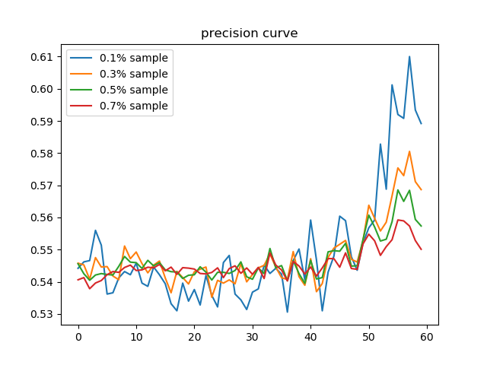

varratio的训练过程中的precision curve

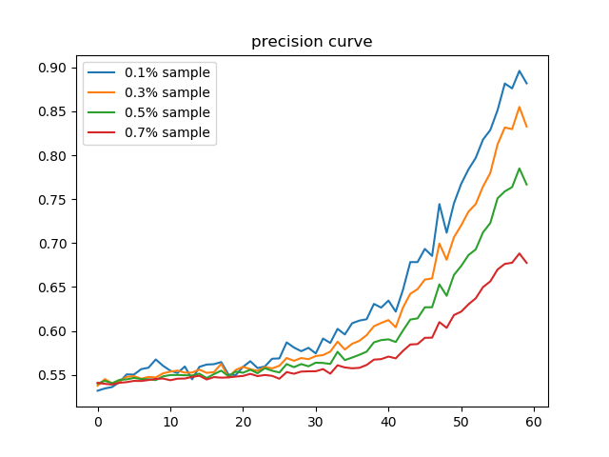

1. 在resnet32上与loss based 方法对比的precision结果

Varratio结果与以上不一致因为learning rate scheduler与网络结构均依据metaweightnet做出了改动

|  |  |  |  |  |
| --- | --- | --- | --- | --- |
| **corruption prob=0.6**  **resnet32**  **epochs=120**  **multistep scheduler(following metweightnet) milestone 80,100**  **reweight norm=none**  **reweight function=exp** | **select the 10% sample with the least weight or largest loss for loss based** | **30%** | **50%** | **70%** |
| metaweightnet | 0.9841 | 0.9788 | 0.9402 | 0.7440 |
| Loss based（正常训练） | 0.9796 | 0.9775 | 0.9395 | 0.7519 |
| var_ratio reweight | 0.7504 | 0.7089 | 0.6696 | 0.6243 |

最后epoch的Weight or loss distribution 图像按顺序：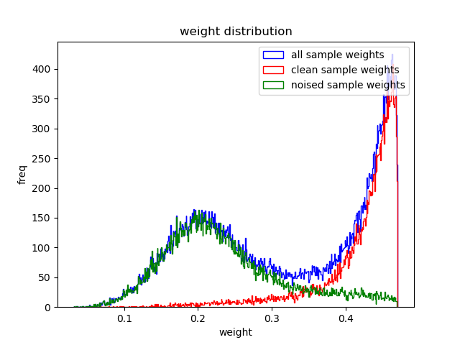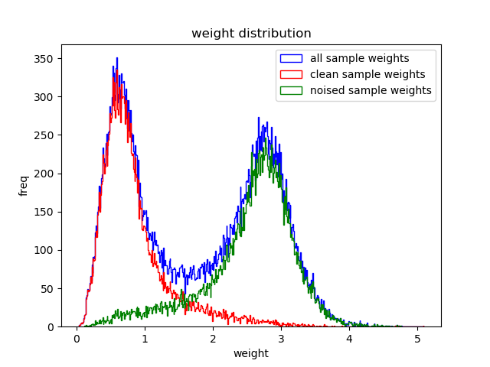

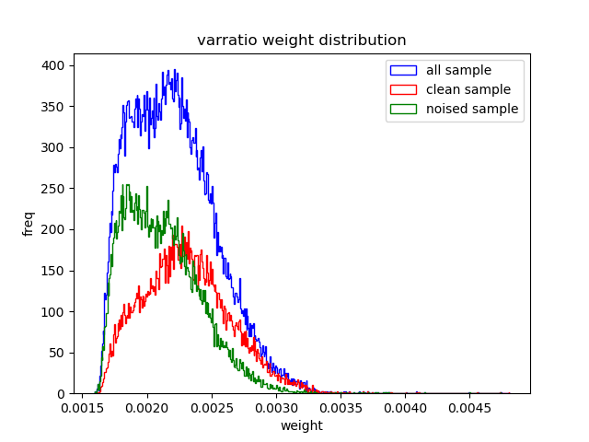

1. 实验结果分析：
   1. Apred precision 过低问题：猜测是因为本身得到apred这个不确定性的表征的方法就代表，这更适合本身除去标签之外的数据本身的质量或者不确定性，比如图片噪音（用PFE）和语义分割中的边缘像素（2017yarin），标签不确定性不是图片本身的性质，于是输入图片然后期望输出标签的不确定性是不合适的。然而为什么确实前10%到后来precision有上升，推测是因为硬把数据集记下来了，每次到有标签错误的样本模型出错可能性更大，训练过程中每到这些样本apred预测值更大的话总体loss会小。apred这样实际上是想把标签错误样本与没错样本的图片本身分开，这肯定是不可分的，因为本来语义上他们都是同一个数据集中随机选出的，而且也是不连续的，一个标签出错的图片附近可能都是未出错图片。所以我原来的问题在于高估了神经网络这种强行记忆的能力，认为在训练过程中神经网络能够先强行记下来每一个样本（也就是学会给每一个样本一个正确的apred值），再根据这个来进行分类，但是显然它能记下来一些，但是远远不够说还要把这些用来reweight的程度。于是在这个任务中apred的precision不高，正确率也不会比none reweight高很多，甚至因为改变了平均的weight导致正确率下降。
      1. Apred的目标：图像本身映射到不确定性预测值
      2. 一个好的任务：图像本身蕴含了不确定性的信息
      3. 现在的任务：图像本身确实蕴含了，但是是因为数据集里面这个图像和他是不是噪音这个布尔值是绑定的，跟图像本身的内容没关系
   2. Loss依据的理由：标签类预测值越低越像噪声
      1. 缺点是模型可能很确定地出错，这一点可以尝试用mcsample来解决，但是训练的过程中不太可能出现这个问题
      2. 其他缺点暂时找不到（noisy label的task中，有不属于训练数据中所有类型的新数据这种任务未考虑），因为确实标签类的预测值越低，是噪声的概率也就越高
   3. Varratio依据的理由：预测值每一类越平均越像噪声
      1. 收敛后precision低：但是，当非标签类的实际正确类预测值很高的时候（这意味着此时模型训练已经学到很多东西），实际上是不平均的，不会被选为varratio的前10%，而这种肯定是噪音样本，所以precision收敛后varratio比不过loss
      2. 收敛速度慢
   4. 做实验查看了，两种依据前10%重合的程度，与以上预测符合，仅0.03，随机应该是0.1，那么就代表了确实存在varratio将太像噪声（数据及标签类的概率太小）的样本认为反而不是噪声的现象

# 提出方法主题实验

### 第一步与第二步：尽可能找到更好的甄别noise的不确定性表征&各种与不确定性表征相匹配的weight function

噪声甄别率的计算都是用自己的方法来做reweight然后在relabel的时候用同一种方法算weight然后计算噪音甄别率。尝试过none reweight正常crossentropyloss来训练然后用var_ratio来计算甄别率，发现这样对其他方法可能不公平，因为像a_pred，metaweight，noisemodeling这种方法没办法用正常的loss训练，a_pred本身也是一种输出

不确定性表征与weight function本身无法解耦，因为不同weight function不同训练过程会影响不确定性的预测，于是计划用下表来寻找规律

#### 提出的（未实现）

\alpha为weight function中超参数，weight=exp(-\alpha*uncer)

|  |  |  |  |  |
| --- | --- | --- | --- | --- |
| Weight  Uncer function  statistics | \alpha=0.5 | 1 | 2 | 4 |
| A_pred | 甄别率&正确率 |  |  |  |
| variance |  |  |  |  |
| entropy |  |  |  |  |
| Var_ratio |  |  |  |  |

### 第三步：尝试分开noised sample与hardcase（未实现）

Varratio可能是想要找hardsample，可以通过半人工的方式来验证，就是看前10%里面pic_idx的真图，然后人工看里面有多少是难样本

#### Reweighting with two stage training

#### Relabeling

#### Relabeling + noise class